Open Government Plan 2016
September 2016
TABLE of CONTENTS

Letter from Chief Information Officer
1. NASA and Open Government
1.1 NASA Organizational Structure
1.2 Cross-cutting Objectives
2. What’s New
2.1 Open Innovation Platforms
2.1.1 Citizen Science
2.1.2 NASA Solve
2.1.3 Center of Excellence for Collaborative Excellence (CoECI)
2.2 Open Data platforms
2.2.1 Open.NASA.gov
2.2.2 Data.NASA.gov
2.2.3 Code.NASA.gov
2.2.4 API.NASA.gov
2.2.5 SpaceAppsChallenge.org
2.3 Women in Data Initiatives
2.4 Federally Funded Scientific Research Data Initiative
2.5 Code Sharing
2.6 Small Business Innovation Research/Small Business Technology Transfer
3. Keeping Track: From Then to Now
3.1 OMB Memo M-16-16
3.2 Historical and Ongoing Activities
Freedom of Information Act
Congressional requests
Declassification
Records Management
Procurement
Web Initiatives/
NASA TV
Education Activities
Space Communication and Navigation (SCAN)
Centennial Challenges
Space Act agreements
Tech Transfer
Engineering Network and NASA Technical Report Server (NTRS)
NASA and Data.gov
Financial Transparency,
Access and Utilization of NASA Science Data/
Office of the Chief Information Officer (OCIO)
Open Innovation Projects/
Open Data
Open Source Software
Technology Accelerators
Prizes and Challenges
Citizen Science
Educational Infrastructure
Zero Robotics
IT Labs
PhoneSat
Center of Excellence for Collaborative Innovation (CoECI)
Scientific and Technical Information (STI)
Collaborative Spaces
Open Government Directory
Collaborative Code Repository/
Digital Strategy
Proactive Disclosures/
Public Notice
Privacy
Whistleblower Protection
3.3 Flagship Initiatives: Historical Plan Matrix
Open Source Software Development
NO LONGER ACTIVE: Nebula Cloud Computing Platform
Participatory Exploration Office
NASA Web Environment
Climate Data Initiative
NASA Information Architecture and Management (NIAM)
Asteroid Grand Challenge
4. Conclusion

Letter from the Chief Information Officer

NASA’s human exploration, science, and technology endeavors are intertwined. My vision aligns with the Agency’s…to “unleash the power of data to reach new heights, reveal the unknown, for the benefit of all humankind.” We can accomplish this by approaching our work with a mindset to better serve our internal information technology customers at NASA, and better equip and involve the public to solve problems using NASA’s data and tools.

We’re at a crossroads where the security of NASA’s information and information technology assets is occasionally at odds with the tenets of collaboration, transparency, and openness. We owe the Nation our greatest efforts to remain vigilant against threats. We’re working hard to ensure that when we open the doors to our information, it can be accessed in ways that protect the public, our employees, and our work.

This fourth Open Government Plan is a celebration of new initiatives for public participation, as well as employee collaboration. The plan offers new pathways for public involvement, and provides a roadmap, in matrix form, to track past performance from the initial 2010 Open Government Plan through today. We’ve embraced open government principles and endeavored to build upon the initial open government activities by leveraging these early learnings and best practices.

We’ll continue to encourage innovation and creativity as we develop solutions to perplexing problems. We commit to remain open and transparent while safeguarding NASA’s national assets and data treasures.

Renee Wynn
NASA’s Chief Information Officer

1. NASA and Open Government
NASA is an open government agency based on the founding legislation in the National Aeronautics and Space Act of 1958, which calls for participation and sharing in the conduct of how we go about the business of expanding the frontiers of knowledge, advancing understanding of the universe, and serving the American public.

NASA Space Act (as amended), Section 203
(a) The Administration, in order to carry out the purpose of this Act, shall—
(1) plan, direct, and conduct aeronautical and space activities;
(2) arrange for participation by the scientific community in planning scientific measurements and observations to be made through use of aeronautical and space vehicles, and conduct or arrange for the conduct of such measurements and observations;
(3) provide for the widest practicable and appropriate dissemination of information concerning its activities and the results thereof;
(4) seek and encourage, to the maximum extent possible, the fullest commercial use of space; and
(5) encourage and provide for Federal Government use of commercially provided space services and hardware, consistent with the requirements of the Federal Government.

From 2010 to date, NASA’s Open Government Initiative has matured, evolved, and adapted to shifting priorities in leadership from the White House, Office of Management and Budget, and NASA executives. The original tenets have not changed; however, the application of open government principles -- participation, transparency, and openness -- are applied according to priorities of agency leadership.

1.1 NASA Organizational Structure
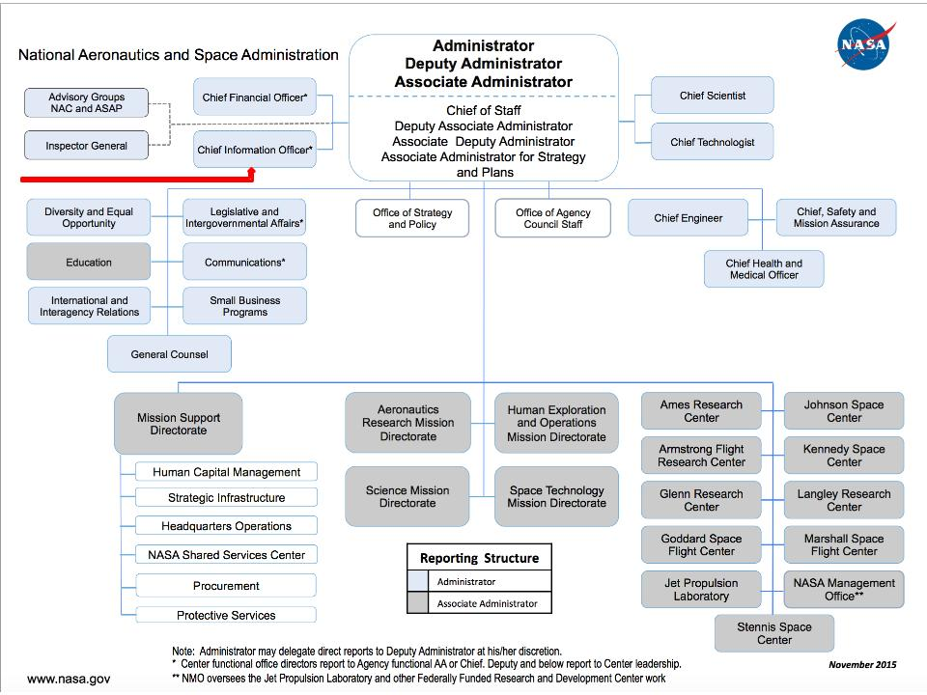

More than 18,000 civil servants wear the NASA badge to work each day, in addition to 52,000 contractors across the United States and overseas. Infusing open government principles starts at the top with agency leadership, but is also bubbles up from all levels of the organization through enthusiastic civil servants and contractors who innovate and collaborate as a normal way of doing business. The shape and tone of strategic direction from the top reflects the individuals who serve in leadership positions, and determines what priorities we place on individual initiatives that serve as proving ground for open government tenets. Here at NASA, we’ve seen significant changes in leadership over the years, yet the commitment to open government remains solid. From the original Open Gov Plan in 2010 to today, NASA’s top leadership changed, as well as management of the Open Government Initiative. In fact, three different teams shepherded the process, each bringing a unique perspective on how open government should be managed and implemented. In addition, the White House leadership of the Open Government effort has changed hands, thereby shifting priorities and interpretations for implementation. Each of the four Open Gov Plans, including this one, reflects the guidance provided to federal agencies by the White House, as well as the progress and priorities reflected by the NASA teams.

For this report, our team took a look at what’s new since the last Open Gov Plan, and provided an overview of how we plan to go forward. In addition, we’ve provided a matrix with activities from each of the previous reports to provide an analysis of what we said we would do, and what we actually accomplished.

1.2 Cross-cutting Objectives
The first two Open Gov Plans cited the following five cross-cutting objectives, which still apply:
- Increase Agency transparency and accountability to external stakeholders,
- Enable citizen participation in NASA missions (prizes and challenges, citizen science),
- Improve internal NASA collaboration and innovation,
- Encourage partnerships that can create economic opportunity, and
- Institutionalize Open Gov philosophies and practices at NASA.

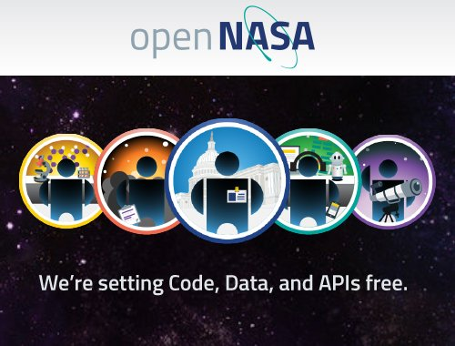
As evidence of meeting these objectives, we provide some high level examples. The interactive open.NASA.gov website provides an umbrella for citizens to find NASA’s activities sorted by user personas -- such as citizen scientist, civic activist, developer, federal worker, or curious browser -- for easy access to relevant information -- enabling transparency and accountability for the open government initiatives, as well as citizen participation, collaboration and innovation.

The Open Data page provides links to sister websites: data.NASA.gov, code.NASA.gov, api.NASA.gov, and more. In addition, the website offers an Explore With Us section that links to citizen engagement initiatives, including the NASA Solve website that lists all NASA prizes and challenges, as well as citizen science information. NASA has a rich history leveraging partnerships -- from international collaboration for missions, such as the International Space Station, which includes 15 nations from the U.S., Russia, Canada, Japan, and the participating countries of the European Space Agency. NASA actively leverages authority provided under the 1958 Space Act to enter into partnerships with domestic and international organizations, called Space Act agreements (more information provided in the Matrix below). Currently, NASA has 1213 active domestic agreements and 760 international agreements.

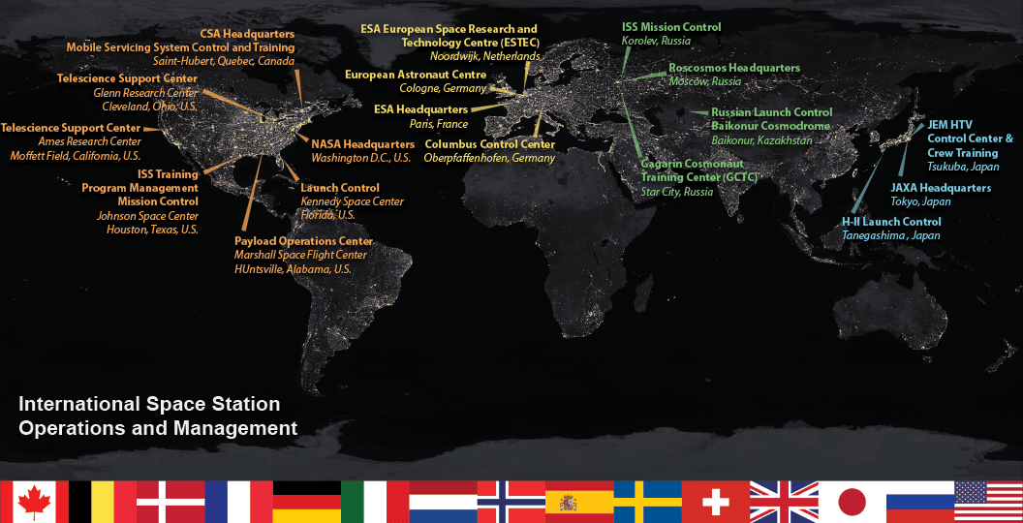

The final cross-cutting objective, to institutionalize open government principles is evident in the growth of open innovation engagements as part of mission planning, and in the creation of the Center of Excellence for Collaborative Innovation (CoECI) which provides institutional support mechanisms for teams and organizations who want to engage in open innovation projects that foster collaboration and citizen engagement. In addition, NASA established dedicated staff members to shepherd the challenges and prize competition portfolio and Centennial Challenges out of the Space Technology Mission Directorate, citizen science activities under the auspices of the Office of the Chief Scientist, and open data and open innovation initiatives within the Office of the Chief Information Officer.

2. What’s New
Since the last Open Gov Plan in 2014, we’ve made significant progress enriching and enhancing the foundations laid by previous Plans. Though some of these activities listed in this section are not new, we’ve added new capabilities and capacities to continue this good work, as we move forward into the next two years. Here is a top-level look at projects we love. And by the participant response we’ve seen so far, you love them too.

2.1 Open Innovation Platforms
Over the next two years, NASA plans to continue adding innovative opportunities by leveraging all these platforms: citizen science, prizes, and challenges.

2.1.1 Citizen Science
Citizen science is beginning to flourish as an innovation tool. Though these opportunities are listed as part of NASA Solve, the agency saw the need for an overarching coordination effort. The Office of the Chief Scientist convened an intra-agency Citizen Science Working Group to share ideas and best practices, and support creation of new citizen science opportunities with upcoming NASA missions. For example, the Working Group is planning a Red Planet Workshop to bring together members of the Mars community, NASA officials, and innovative thinkers to devise ways to leverage public ingenuity to participate and collaborate with NASA as we explore Mars.

2.1.2 NASA Solve
Since the last Plan, NASA created NASA Solve as a gateway for citizens to engage in the agency’s aerospace program through challenges, prize competitions, and crowdsourcing. Under the leadership of NASA’s Office of the Chief Technologist, an intra-agency working group worked to design and populate the website, which is intended as an invitation to members of the public to contribute their time and expertise to advancing research, solving problems, and potentially winning prizes as a result of their work. Specific projects listed on the site include crowdsourced challenges and prize competitions, citizen science projects, and competitions aimed at advancing student education, and many more activities. Through NASA Solve citizen opportunities, we’ve accomplished significant innovation and technologic development at NASA. Included in the accomplishments are a team that claimed over $1.3 million dollars for a fuel efficient aircraft, a team that won $500,000 for building a regolith collecting robot, and a pair of men who collected a combined $300,000 for their astronaut glove prototypes.

2.1.3 Center of Excellence for Collaborative Innovation (CoECI)
Though not new, NASA’s Center of Excellence for Collaborative Excellence (CoECI) continues to provide a platform for innovators within NASA and across the federal government to generate ideas and solve important problems by working with global communities. CoECI provides guidance to NASA and other Agency teams on all aspects of implementing challenge-based initiatives, from problem definition, to incentive design, to post-submission evaluation of solutions. This end-to-end service has allowed and continues to allow other agencies to rapidly experiment with these new methods before standing up their own capabilities. CoECI administers an internal virtual collaboration platform, NASA@Work seeks to increase innovation by fostering collaboration within our NASA community through the contribution of interactive discussions and the submission of solutions to open challenges. In addition to coordinating crowd-based challenges, CoECI supports technology scouting services, which provide a broad external network of experts as potential collaborators based on a specific technological need from an organization.

2.2 Open Data platforms

Developers, technologies, entrepreneurs, citizen scientists, and more can contribute to NASA’s mission by creating new insights and solutions through NASA’s open data. The Open Innovation team identifies, catalogs, registers, and releases open datasets and metadata records through several avenues, such as Application Program Interfaces (APIs), Public Data Listings. We work with data owners across the agency to promote open data policies and facilitate plumbing to dynamically automate rollup of siloed NASA data into open data registries. For external data release, we federate data to key stakeholders and the public through data.nasa.gov, api.nasa.gov, and the interagency data.gov registries. NASA will continue to enhance to these websites, and add new citizen-relevant websites.

2.2.1 Open.NASA.gov
For the existing websites managed by our Open Innovation team, we’ve redesigned, added tools and capabilities, and created sister sites. As described earlier, we redesigned and enhanced the Open.NASA website to provide easy access for relevant open data and open government-related initiatives. Here is a brief overview of new capabilities added to the portfolio.

2.2.2 Data.NASA.gov
Data.NASA is the public face for NASA’s Open Data movement and is federated with the cross-agency data.gov system. The Data.NASA website and services offer capabilities to enable users, whether NASA employees, officials, or citizens, the ability to discover, collaborate, interact and share around NASA open data. The site portrays open data with three motifs: developers, stories, and data. At the heart of the site is the main NASA data registry that allows users to search metadata records of NASA data that exist on NASA authoritative sources, view and interact with hosted data through APIs, gain insight and developer details on NASA APIs, and collaborate and create visualizations on the fly with NASA data. The site allows users to maintain profiles, which enables creation of data communities. The site is integrated with the open.NASA.gov web platform as well as NASA’s API management System on API.NASA.gov.

2.2.3 Code.NASA.gov
Code.NASA is an online catalog of software projects released via the NASA Software Release process and contains products from every field center. The site is community-driven, enabling developers to register their open source projects into the Open Source Catalog and promote their software. The team is working to expand the capabilities of code.NASA.gov to include a tighter integration with GitHub, and provide visibility into the daily activities by members of NASA organizations. The intent is to enable site users to see an up-to-the-minute snapshot of development activities for NASA projects, with detailed insight into milestones, bug fixes, new project features.

2.2.4 API.NASA.gov
API.NASA is a new website in the suite of open data platforms. It is the first website of its kind in the federal government, and provides capabilities to catalog and document call-level usage of Application Programming Interfaces. This management platform provides features for API keys, caching, hooks for analytics, rate limiting, and interactive documentation. This effort additionally includes reaching out to missions and programs to consolidate and standardize APIs within the agency.

2.2.5 SpaceAppsChallenge.org
The team redesigned the Space Apps website to align with the Open.NASA.gov look and feel, and to leverage capabilities developed for the Open.NASA website -- using the same content management system. The team added security procedures to ensure citizens who create location and project pages have license rights for images and video content. Public voting for the People’s Choice Award was incorporated into the website, as well as the ability to embed virtual streaming from international sites around the world.
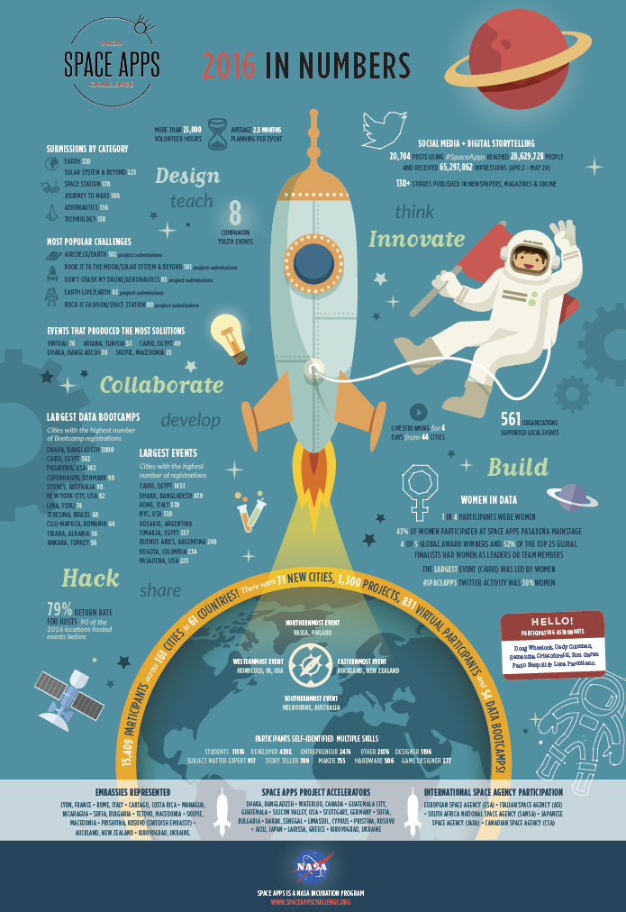

2.3 Women in Data Initiatives
For the last five years, NASA hosted the International Space Apps Challenge. With over 15,000 participants in 2016 coming together over a weekend to create nearly 1300 innovative solutions, Space Apps is more than an open data watering hole. It has proven to be an unexpected, yet reliable, focus group on the usability of NASA data and what datasets are most compelling and relevant, as well as eyes and ears into fledgling innovation communities around the world. In addition, Space Apps gives us insight into the state of women in data science.

In 2014, the Open Innovation team noticed a disparity in the ratio of Space Apps participants -- roughly 80% men to 20% women. We embarked on a quest to better understand how to attract more women and girls to data by conducting a year-long study, which included a literature review followed by dozens of interviews with leading women’s organizations in the data, tech, and startup communities.

As we dug into the literature, we found the Space Apps ratio reflects national trends. While women in the United States earned 57% of all bachelor’s degrees since the late 1990s, only 18.2% are in the field of computer sciences, according to the 2015 National Science Foundation report on “Women, Minorities, and Persons with Disabilities in Science and Engineering.” In 2013, women only represented 26% of the professional computing workforce, a sharp decrease from 35% in the 1990’s, according to the American Association of University Women “Solving the Equation” study. A 2002 “Women in Computing Around the World” study suggested that the gender gap in STEM and computing is inconsistent across cultures, with the lowest participation rates among women in the US, UK and Australia. And, the gap is widening. We supplemented the research with interviews, which led us to a key takeaway: women seek a welcoming, collaborative environment to try out new skills, as well as early opportunities to engage and team before events.

Based on this research, the team created two initiatives: Data Bootcamp, a one-day introduction to coding; and NASA Datanauts, a year-round engagement to learn and practice data science skills. Data Bootcamp 2016 was held in 54 locations with 5700 participants who were introduced to NASA data, code, and data science. For Datanauts 2016, the team designed and implemented the concept, and built an interactive user dashboard for data engagements to learn and practice coding and data science. For the six-month engagement, Datanauts can collaborate on monthly challenges and individually work on focused code skill tracks for beginners and advanced coders, including a track to create a open-source code library for orbital dynamics enthusiasts. The current class of 50 Datanauts represent a balance of experiences and skill levels with artists, designers, software developers, and more; who range from beginners to expert coding levels. 45 women and five men will serve as beta-testers of the content and interactions created by the team. The design fosters a collaborative environment for the class members to learn from each other.

NASA plans to continue these efforts over the next two years by adding new Datanauts and new initiatives to attract women and girls.

2.4 Federally Funded Scientific Research Data Initiative
NASA published its Plan for Increasing Access to the Results of Federally Funded Scientific Research. The plan meets the intent of the February 22, 2013 Office of Science and Technology Policy (OSTP) Memorandum directing all agencies with more than $100 million in annual research and development expenditures to prepare a plan for improving access to the research results. NASA invests $3 billion each year for technology development, and fundamental and applied research. The plan calls for effective data management to increase discovery and efficient use of federal resources; preservation and sharing of data; flexibility in program-specific needs and requirements; recognition and preservation of data rights; and protection of privacy and confidentiality, as appropriate. The plan clarifies roles and responsibilities for different organizations within NASA and for the research investigators and their institutions.

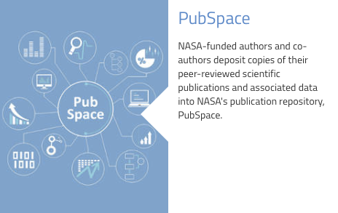
NASA just debuted a new research portal in the summer of 2016 with the following features:
PubSpace: an archive of original science journal articles produced by NASA-funded research and available online without a fee. The data will be available for download, reading and analysis within one year of publication;
Data Management Plan: guidelines for researchers receiving NASA-funded grants, cooperative agreements, and contracts to develop data management plans as part of their NASA funding proposals; and access to policy documents and training videos, as well as extensive FAQs. This is one more vehicle for citizens to engage with NASA's universe of data and research results. We'll keep adding to the portfolio of publications, and hope to see new research from the data we make available to citizens. This portal links directly to the link to our Data.NASA site, and the Open.NASA website directs traffic back to the research portal. You can contact the team with questions or requests for support at: publicresearchaccess@nasa.gov.

2.5 Code Sharing
The Open Innovation team will continue to spearhead code sharing related initiatives for the agency. This will include participating in cross-agency working groups and standards bodies as well as being the main POC between OCIO and Technology Transfer offices. The code sharing initiative will manage several prototypes, including a Federated Code Sharing system, which will unify existing disparate code repositories across the agency as well as spearhead the infusion of best-of-breed Code Sharing platforms using COTS and Open Source to conduct prototyping and elicitation of requirements. Also, this team is responsible for working with agency Software Release Authorities to promote approved software projects to Open Source and work with development teams to publish collaborative projects on GitHub.com. This team will help implement the August 8, 2016 Office of Management and Budget M-16-21 Memorandum: Federal Source Code Policy: Achieving Efficiency, Transparency, and Innovation through Reusable and Open Source Software.

NASA plans to create an inventory of shared code and to increase capabilities for federal agencies to share custom code.

2.6 Space Technology Innovation Opportunities
The nation’s investments in space technology enable NASA to make a difference in the world around us. The Space Technology Mission Directorate is responsible for developing the crosscutting, pioneering, new technologies and capabilities needed by the agency to achieve its current and future missions. The organization works to rapidly develop, demonstrate, and infuse revolutionary, high-payoff technologies through transparent, collaborative partnerships, expanding the boundaries of the aerospace enterprise. Citizens can participate in the adventure of space through the Small Business Innovation Research (SBIR)/Small Business Technology Transfer (STTR) programs, which operate in three phases: 1) to establish the scientific, technical, commercial merit, and feasibility of the proposed innovation, and the quality and performance of the small business concern (SMC); 2) to develop, demonstrate, and deliver innovation with 24 month contracts with funding up to $750,000; and 3) commercialize innovative technologies, products, and services resulting from the first two phases. In addition, the organization is looking at creating technology startup accelerators over the next two years.

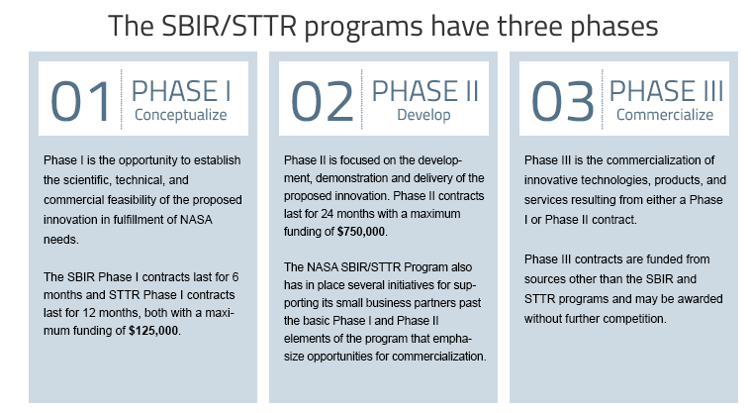

3. Keeping Track: From Then to Now
We heard from citizens that tracking progress across all the Plans [2010, 2012, 2014 and now 2016] is difficult. To address this, we collected all the activities from in previous Plans and created a matrix view for easy reference. Please note that over the years, the titles and focus of some activities changed; though, many activities continue today with little change to the function and focus. A few were completed, closed out, or merged with similar activities. Most of these efforts are embedded in standard business processes now, flourished, and spun off new activities.

3.1 OMB Memo M-16-16

OMB Memo M-16-16, dated July 14, 2016, provided guidance for agencies. The recommended sections are listed below with corresponding M-16-16 memo page numbers and section identifiers that you will see in the Matrix for historical and ongoing activities, and flagship initiatives.

New and Expanded Initiatives (listed with memo page number and section identifier):
2(A) Open Data
3(B) Proactive Disclosures
3(C) Privacy
3(D) Whistleblower Protection
3(E) Websites
4(F) Open Innovation Methods
4(G) Access to Scientific Data and Publications
4(H) Open Source Software
4(I) Spending Information
Ongoing Initiatives
5(A) Transparency Initiatives
5(B) Public Notice
5(C) Records Management
5(D) Freedom of Information Act (FOIA)
5(E) Congressional Requests
5(F) Declassification
5(G) Public Participation
5(H) Collaboration
6(I) Flagship Initiatives

3.2 Historical and Ongoing Activities
For easy reference, each activity in the matrix below designates the Plan version -- 2010, 2012, 2014, and the current 2016 Plan; as well as the page number on which each activity is mentioned. We’ve applied the M-16-16 Memo designations in bold [i.e. 2(A) for Memo page 2 section A] in the second column of matrix next to the notation of the 2016 Plan in the first column.

Plan | Page | Activity | Description | Ongoing | Complete | Closed
2010 | 26 | Freedom of Information Act  (FOIA)  [Note: Also referenced in Proactive Disclosures] | NASA’s FOIA program provides access to agency documents through a citizen-centered service. NASA is committed to providing the public with excellent customer service as well as access to disclosable agency documents in accordance with all appropriate laws and regulations. Each Plan listed improvements, consolidations, and revised processes. Each of these commitments was met, and the effort to provide excellence continues.  http://socialforms.nasa.gov/foia |  | x
2012 | 44 |  |  |  | x
2014 | 18 |  |  |  | x
2016 | M-16-16  5(D) |  |  | x
2010 | 29 | Congressional requests  NASA Policy Document (NPD) 1450.4G  Handling Congressional Correspondence and Information Concerning Congressional Activities  NPD 7010.1K  Processing of Legislative Proposals for Incorporation into NASA Authorization Legislation. | NASA’s Office of Legislative and Intergovernmental Affairs (OLIA) provides executive leadership, direction, and coordination of all communications and relationships, both legislative and nonlegislative, between NASA and the United States Congress as well as state and local governments.  Organizational leadership:  + Seth Statler Associate Administrator  + Chris Flaherty Acting Director Legislative Liaison  +Maureen Muncy Director Legislative Reference and Analysis  +Lisa Stewart Director Outreach and Intergovernmental Affairs  You can browse policy documents, as well as upcoming hearings and archived congressional testimony,  You can contact them directly:  National Aeronautics and Space Administration  Office of Legislative Affairs  Washington DC 20546  Phone 202.358.1055  Fax: 202.358.4340 |  | x
2014 | 18 |  |  |  | x
2016 | M-16-16  5(E) |  |  | x
2010 | 31 | Declassification  NASA Procedural Requirements NPR 1600.  Records Disposal  Title 44, U.S. Code | NASA adopted classification policies and issued regulations that comply with the requirements of federal security classification reform. NASA Classified National Security Information,” NPR 1600.2, establishes Agency procedures for the proper implementation and management of a uniform system for classifying, accounting, safeguarding, and declassifying national security information generated by or in the possession of NASA. Classification occurs in different flavors. Mandatory declassification occurs in response to a request for declassification that meets the requirements under section 3.5 of the Order. Automatic declassification occurs on a specific date or event as determined by the OCA or the expiration of a maximum timeframe for duration of classification established under the Order. Systematic declassification occurs upon review of classified information contained in records that have been determined by the Archivist (National Archives and Records Administration) to have permanent historical value in accordance with Title 44, U.S. Code.  To date, NASA declassified:  71,022 pages by automatic declassification, 2400 pages as a result of systematic declassification, and 583 pages of mandatory review. Of all the pages review, NASA only exempted 1%. |  | x
2014 | 17 |  |  |  | x
2016 | M-16-16  6(F) |  |  | x
2010 | 33 | Records Management  NPD 1440.6l NASA Records Management  NPD 1441.1E  NASA Records Management Program Requirements  NRRS 1441.1, NASA Records Retention Schedules | NASA records document the Agency’s business: organizations, policies, decisions, achievements, and operations -- in the form of paper, audio/visual, micrographics, and electronic media.  The objectives of NASA records management are to: make current and inactive records available for public use, preserve significant records for future engineers and our Nation’s history, and legally dispose of all others.  NPD1441.1E updates are complete. The NRRS1441.1 Retention Schedules are updated on an ongoing basis.  NASA Records Officer:  Patti F. Stockman  http://www.nasa.gov/content/nasa-records-management |  | x
2014 | 17 |  |  |  | x
2016 | M-16-16  5(C) |  |  | x | x
2010 | 36 | Procurement | The mission of the Office of Procurement is to “deliver optimal business solutions” to support NASA, using “acquisition excellence in an evolving environment.”  Since 2013, NASA awarded $35 billion to 65,805 prime contracts; and $1 billion to 8,535 grants. This information is available through usaspending.gov. | x
2010 | 39 | Web Initiatives/  Websites  [NOTE: Also referenced in the Flagship matrix. NASA’s Web Environment was a 2012 Flagship initiative.]  NASA Policy on the Release of Information to News and Information Media | NASA’s web environment is well known for providing a wealth of public information citizens, scientists, researchers, educators, and students, and is critical in fulfilling the agency’s statutory requirement to disseminate information about its programs to the widest extent practicable. To external audiences, NASA personnel use these websites and services to support NASA’s core business, scientific, research, and computational activities.  Today, NASA.gov attracts on average about 1.5 million visits each day, with nearly 350 million visits so far in 2016 (Jan 1, 2016 to Jul 31,2016). NASA.gov also currently serves as a hub for NASA’s social media presence, All the accounts are listed and maintained at https://www.nasa.gov/socialmedia  NASA has taken the view that social media is a medium where the message is what matters. Instead of a formal policy, NASA applies existing agency rules, guidelines, and policies employees are already familiar with (and are all public). |  | x
2012 | 20 |  |  |  | x
2014 | 13 |  |  |  | x
2016 | M-16-16  3(E) |  |  | x
2010 | 42 | NASA TV | NASA’s television availability on cable television systems, satellite television services, and NASA.gov enables citizens and international audiences to view NASA missions, news conferences, and other activities real time. NASA’s 2010 Plan included upgrades to high definition video, and on demand content. These goals are complete.  NASA continues to upgrade and enhance the NASA TV experience.  +How to get NASA UHD TV content (710 KB PDF)  +List of Upcoming Live +EventsNASA TV Video File +RundownFinding NASA TV on Satellite AMC-18cNASA-Related  +Programming on Other TV Channels  http://www.ustream.tv/nasahdtv | x | x
2010 | 44 | Education Activities | NASA’s Education website is the central gateway for students, teachers, parents, and citizens to access NASA mission and education content. Content included the Education Calendar, internship and fellowship applications, and a list of all programs and initiatives. Users can subscribe to the Education Express, a weekly email highlighting education opportunities.  The original 2010 Plan included goals for online collaborative tools, an internal and external engagement plan, and strategies to include feedback loops. All these elements are part of the current website.  http://www.nasa.gov/offices/education/about/index.html  http://www.nasa.gov/offices/education/programs/descriptions/All_Alpha.html  http://www.nasa.gov/audience/foreducators/Express_Landing.html  http://www.nasa.gov/sites/default/files/atoms/files/nasa_education_implementation_plan_ve4_2015-2017.pdf | x | x
2010 | 48 | Space Communication and Navigation (SCAN) | Reliable space communications and navigation (SCaN) networks are the backbone of all NASA missions, and are comprised of the Near Earth Network (NEN), the Space Network (SN) and its related Tracking and Data Relay Satellite System (TDRSS) of the geo-stationary satellites, and the Deep Space Network (DSN). The original 2010 Plan goals included participation in TV and video projections, and to enable high definition broadcasts for space. These goals have been met, and SCaN continues to provide the link between humans on Earth, and in low Earth orbit on the International Space Station, and humanity’s spacecraft exploring the universe.  https://www.nasa.gov/directorates/heo/scan/index.html | x | x
2010 | 51 | Centennial Challenges  [M-16-16 5(G) Public Participation]  National Aeronautics and Space Act of 1958  Public Law #85-568, 72 Stat., 426. Amended to add Section 304 | The Centennial Challenges program received Congressional authorization in 2005, providing NASA with the ability to use appropriated funds for prize competitions. The Agency continues to lead the federal government in ways to leverage inputs from ordinary citizens and by testing out new platforms for prizes and competitions.  The Centennial Challenge program continues to grow, with many new challenge ideas explored each year. Since 2005 NASA has supported 15 challenges and awarded a total of $6.532 million in 11 of those challenges.  So far, in FY16 NASA:  · Opened 2 new challenges: Vascular Tissue Challenge ($500K), Space Robotic Challenge/ Virtual Competition ($1M)  · Continued 2 challenges: 5th year (and final) Space Robotic Challenge and 2nd year (and final) of Mars Ascent Challenge  · Expects to open 1 challenge: 3D Printed Habitation Challenge (Phase 2 and Phase 3)  · Plans 6 potential future challenges (currently in formulation); with 2 expected to be opened in FY17. | x | x
2010 | 54 | Space Act agreements  [M-16-16 5(H) Collaboration]  NPD 1050.1l | The National Aeronautics and Space Act (the Space Act) provides NASA with the unique authority to enter into a wide range of "other transactions," commonly referred to as Space Act Agreements (SAAs). The Agency enters into SAAs with various partners to advance NASA mission and program objectives, including international cooperative space activities. In the interest of promoting transparency in regard to such transactions, NASA will be posting summary data for SAAs with U.S. commercial and non-profit partners, as well as for our international agreements. These reports are updated and posted on the following website on a quarterly basis:  https://www.nssc.nasa.gov/saa.  Currently, NASA has 1213 active domestic agreements and 760 international agreements.  You can browse the agreements:  Domestic Space Act agreements  International Space Act agreements |  | x
2010 | 57 | Tech Transfer | “The NASA Space Act of 1958 and a series of subsequent laws identify the transfer of Federally-owned or originated technology as a national priority. Technology transfer promotes commercial activity, encourages economic growth, and stimulates innovation in business and commerce.” These resources are housed in NASA’s Technical Reports Server (NTRS) which is part of NASA’s Scientific and Technical Information (STI) program  Citizens can search for tech transfer news and reports: http://www.sti.nasa.gov. For seed funding to support small business research and tech: http://sbir.nasa.gov | x | x
2010 | 61 | Engineering Network and NASA Technical Report Server (NTRS)  [Also referenced in Proactive Disclosures and STI.] | The NASA Engineering Network from the 2010 plan is now part of part of NASA’s Scientific and Technical Information (STI) program. Collected from U.S. and international sources, STI is organized according to content prior to being added to the NTRS Registered, which is a world-class collection of STI that includes over 4 million bibliographic records and a growing number of full-text documents: http://www.sti.nasa.gov.  Information Desk:  help@sti.nasa.gov or  HQ-STI-INFODESK@mail.nasa.gov  757-864-9658  NASA Lessons Learned Information System: http://llis.nasa.gov | x | x
2010 | 65 | NASA and Data.gov  [Transparency Initiatives]  NM 1382-42, NASA Principles and Policies on Scientific Openness  NPR 2810.1, Security of Information Technology  NPD 2810.1, NASA Information Security Policy  NPR 1600.1, NASA Security Program Procedural Documents, Section 5.24 Sensitive But Unclassified (SBU) Controlled Information | In the original 2010 plan, DATA.gov was just forming. Now NASA’s public data lists are harvested onto DATA.gov via NASA’s https://data.nasa.gov website.  Due to the sensitive nature of our data, data release is governed by a number of internal directives, which are listed in the third column to the left.  USAspending.gov -- see Financial Transparency/Spending Information | x | x
2016 | M-16-16  5(A) |  |  | x
2010 | 70 | Financial Transparency.  [Also Spending Information and Transparency Initiatives]  Chief Financial Officers Act of 1990 (CFO Act), Public Law 101-576  Government performance and Results Act (GPRA) of 1993  Federal Funding Accountability and Transparency Act (FFATA) of 2006  American Reinvestment and Recovery Act of 2009 | The Office of the Chief Financial Officer (OCFO) provides leadership for the strategic planning, performance reporting, budget analysis, justification, control, and reporting of all Agency fiscal resources; develops the Agency’s detailed strategic plan and performance reports; leads the Agency’s planning, programming, budgeting, and execution process; oversees all financial management activities relating to the programs and operations of the Agency; monitors and reports the financial execution of the Agency budget.  +David Radzanowski, Chief Financial Officer  Data about spending for NASA contracts, grants, loans, and other financial assistance is available at USAspending.gov.  NASA continues to provide budget and planning documents available for citizens on one location:  http://www.nasa.gov/news/budget/index.html  +Agency fact sheet: NASA's FY 2017 budget request (320 KB PDF)  +FY 2017 budget estimates (11.2 MB PDF)  + FY 2017 budget proposal presentation (2.3 MB PDF)  + FY 2017 budget mission directorate fact sheets (169 KB PDF)  + NASA Aeronautics 10-Year American Aviation Plan (50 KB PDF)  + OMB fact sheet: NASA's FY 2017 budget request (121 KB PDF) | x | x
2016 | M-16-16  4(I)  5(A) |  |  | x
2010 | 74 | Access and Utilization of NASA Science Data/  Access to Scientific Data and Publications  OSTP Memo  Feb 22, 2013  NM 1382-42, NASA Principles and Policies on Scientific Openness  NPR 2810.1, Security of Information Technology  NPD 2810.1, NASA Information Security Policy  NPR 1600.1, NASA Security Program Procedural Documents, Section 5.24 Sensitive But Unclassified (SBU) Controlled Information | NASA published the “Plan for Increasing Access to the Results of Scientific Research: Digital Scientific Data and Peer-Reviewed Publications” on December 2014 in response to the Executive Office of the President’s Office of the Science and Technology Policy (OSTP) 02.22.13 memo, “Increasing Access to the Results of Federally Funded Scientific Research.”  NASA archives all science mission data products to ensure long-term usability and to promote wide-spread usage by scientists, educators, decision-makers, and the general public. Communities of practice within these disciplines and themes are actively engaged in the planning and development of archival capabilities to ensure responsiveness and timely delivery of data to the public from science missions. http://science.nasa.gov  Citizens can explore scientific data in the public catalog on https://data.nasa.gov/: applied science, earth science, and space science.  Science data and information policy: http://science.nasa.gov/earth-science/earth-science-data/data-information-policy/ |  | x
2016 | M-16-16  4(G) |  |  | x
2010 | 78 | Office of the Chief Information Officer (OCIO)  E-Government Act of 2002 (Public Law 107-347) | The OCIO provides information infrastructure and tools that adapt and evolve to support management, science, research, and technology programs, and adheres to the E-Government Act of 2002 which seeks to increase opportunities for citizen participation, promote interagency collaboration, improve efficiency and effectiveness, reduce costs, promote better informed decision-making, promote access to high quality information and make the government more transparent and accountable.  In the original 2010 Plan, NASA set out to establish Chief Technology Officers for Information Technology at Headquarters and at each of the ten NASA Centers, which would function as a Council. This currently functions well as an institutional practice at NASA, and the work continues today. NASA also hosted an IT Summit, as planned, and created pilot projects working with the Federal CIO Council.  Citizens can track NASA’s IT spending on contracts and grants. | x | x
2010 | 81 | Open Innovation Projects/  Open Innovation Methods  https://open.nasa.gov | In the original 2010 Plan, NASA instituted three pilot projects through citizen challenges: InnoCentive, Yet2.com, and TopCoder through the Harvard Business School. The pilot projects concluded, and challenges with InnoCentive and TopCoder continue today. They can be found in the NASA Tournament Lab: https://www.innocentive.com/nasa-pavilion/  The effort expanded into a Prizes and Challenges activity, highlighted in 2012 Plan. See more information under Prizes, Citizen Science, and CoECI.  In 2013, the Open Data/Open Gov efforts were placed under a new name, Open Innovation. The current Open Innovation team continues to support citizen engagement initiatives, such as the International Space Apps Challenge, which led to the Women in Data initiative and the development of the Data Bootcamp model and NASA Datanauts, which are discussed under the section on ongoing initiatives.  The Open Innovation team redesigned the website to allow interactive citizen engagement with open data initiatives, as well showcase citizen-generated NASA-curated projects on the Innovation Space and the Data Story sections. We website is the umbrella for the other initiatives: data.nasa.gov, code.nasa.gov, api.nasa.gov, and more  https://open.nasa.gov/ |  | x
2016 | M-16-16  4(F) |  |  | x
2012 | 24 | Open Data | In the 2012 and 2014 Plans, NASA continued to build the internal directory of NASA datasets and identify high value datasets. In addition, NASA committed to enhance opportunities for coordinated Big Data activities.  NASA completed these goals, and continues the effort. To date, NASA surpassed the original goal of 500 datasets, and continues to add datasets. To date, NASA added more than 32,000 datasets to the Public Data List. NASA adds new high value datasets every quarter.  In the data catalog, citizens can sort the data by catalog, popularity, most recent, and more. Citizens can request a dataset, and create visualizations and API’s from the data.  https://data.nasa.gov/  https://data.nasa.gov/data  https://data.nasa.gov/nominate  https://open.nasa.gov/open-data/  NASA created a Big Data Working Group that meets quarterly with internal and external big data experts to look for ways to collaborate and enhance our capabilities. |  | x
2014 | 11 |  |  |  | x
2016 | M-16-16  2(A) |  |  | x
2012 | 27 | Open/Federal Source Software  [Also referenced above in What’s New under Code Sharing; and in Flagship matrix below under Open Source.] | In the 2012 and 2014 Plans, NASA committed to increasing the number of organizations contributing to code.nasa.gov. To date, NASA added 254 code repositories to the inventory through cooperation with missions and project contributors.  Goal: Implement the Federal Source Code Policy and meet 90 and 120 day milestones as well as continuation of public and private collaborative code repositories.  To date, NASA continues work on releasing open source software projects and internally is working toward a “default to open” for NASA source for greater agency re-use. NASA is currently federating internal software repositories to expedite and optimize how NASA source is eventually published as open source. |  | x
2014 | 12 |  |  |  | x
2016 | M-16-16  4(H) |  |  | x
2012 | 30 | Technology Accelerators | International Space Apps Challenge was developed in 2012, with the initial goal to host in 10 international locations the first year.. To date, Space Apps has grown to 161 locations in 61 countries in 2016.  The Plan called for support for one LAUNCH.org Innovator selection event each year, which we exceeded. However, in 2015, NASA discontinued support for the LAUNCH partnership with USAID, State Department, and Nike.  The Plan called for support for two Random Hacks of Kindness events each year which NASA completed. In 2014, NASA discontinued support for the RHoK partnership. | x | x | x
2012 | 35 | Prizes and Challenges  NASA Policy Document 1090.1  [Also referenced in CoECI, Centennial Challenges, and the Open Innovation Platform section above under What’s New.] | The 2012 Plan set goals for Centennial Challenges, NASA Tournament Lab, NASA Innovation Pavilion, and NASA@Work challenges. All these goals were met. The Plan also mentions a Technology Scout/Consortium which is discussed under the Center for Collaborative Innovation. In addition, NASA developed a technology roadmap that focuses the technology partnership approach.  http://www.nasa.gov/offices/oct/home/roadmaps/index.html | x | x
2012 | 39 | Citizen Science  [Also referenced above in What’s New under Open Innovation Platform.] | Increase the number of students and citizen scientists who engage with NASA, specifically for the 2012 Sun-Earth Day Transit of Venus.  To date, NASA hosts citizen science activities in conjunction with major missions. The list of citizen science projects and programs continues to grow. In 2015, the Office of the Chief Scientist created an internal, cross-organizational Citizen Science Working Group to share and coordinate activities across the 10 NASA Centers.  http://science.nasa.gov/citizen-scientists/ |  | x
2016 |  |  |  | x
2012 | 42 | Educational Infrastructure | The original goal, to design and implement an organizational structure that employs a systematic approach to managing information, technology, and communications in the Office of Education is complete.  Donald G. James, Associate Administrator for Education, currently leads the effort to inspire and motivate students to pursue careers in science, technology, engineering, and mathematics by supporting education in the Nation's schools, and to shape and share the experience of exploration and discovery by supporting informal education and public outreach efforts. |  | x
2012 | 45 | Zero Robotics | Zero Robotics is a national competition to let citizens program NASA’s Synchronized Position Hold, Engage, Reorient, Experimental Satellites (SPHERES) inside the International Space Station -- enabling students and space-dwelling crewmembers to collaborate, develop technology, and support STEM education. NASA surpassed the original 2012 Plan goal to engage with 1000 students in two seasons.  NASA no longer funds the program, which is now a partnership between MIT and the National Lab on Space Station, which is run by the Center for the Advancement of Science in Space (CASIS). |  | x | x
2012 | 48 | IT Labs  The name changed to Technology and Innovation Labs. | This effort, originally part of the 2012 Plan, is part of the institutional effort at NASA to solicit ideas within the NASA community, to collaborate incubate, and support early adoption of innovative technology concepts. Renamed Technology and Innovation (T&I) Labs, activities are small scale and generally run 90 days to one year; and operate through cross-organizational partnerships and shared funding to support the incubation period. NASA surpassed the original goal of 10 incubations and 2 pilot projects over 2 years, with a total of 129 projects to date with a over $1 million in seed funds. | x | x
2012 | 50 | PhoneSat | The 2012 PhoneSat activity aimed to remove cost barriers to space participation by citizens with ambitions to launch a small satellite using commercial grade mobile phones, open source platforms and commercial off the shelf components. NASA completed the original 2012 goal to launch PhoneSat in 2012 with additional plans to add heliophysic sensors and a foldable design. Three PhoneSats were delivered to Earth orbit on the maiden flight of the Antares launch vehicle on April 21, 2013 from Wallops Island, Virginia.  http://www.nasa.gov/centers/ames/engineering/projects/phonesat.html |  | x
2012 | 53 | Center of Excellence for Collaborative Innovation (CoECI)  [Also referenced above in What’s New under Open Innovation Platform.] | After a highly successful pilot program to determine if the use of crowdsourcing held potential to positively affect NASA’s ability to accelerate and augment research and development efforts, the Center of Excellence for Collaborative Innovation (CoECI) was established by NASA in November of 2011 at the request of the White House Office of Science and Technology Policy (OSTP) to assist other federal agencies in the use of crowdsourced challenges to solve tough, mission-critical problems. CoECI continues to provide guidance to NASA and other Agency teams on all aspects of implementing challenge-based initiatives, from problem definition, to incentive design, to post-submission evaluation of solutions. This end-to-end service has allowed and continues to allow other agencies to rapidly experiment with these new methods before standing up their own capabilities.  To date, CoECI has administered 95 externally crowdsourced challenges, 15 of which were coordinated for other Federal agencies.  CoECI has also hosted 87 NASA open innovation challenges through the NASA@work internal collaboration platform. NASA@work is an agency-wide, virtual platform that seeks to increase innovation by fostering collaboration within our community through the contribution of interactive discussions and the submission of solutions to posted challenges.  In addition to coordinating crowd-based challenges, CoECI supports technology scouting services, which provide a broad external network of experts as potential collaborators based on a specific technological need from an organization. Since 2012, CoECI facilitated 7 tech scouting initiatives via Yet2.com and is in the process of evaluating expanding tech scouting capabilities through a new acquisition scheduled for FY17. |  | x
2016 |  |  |  | x
2012 | 55 | Scientific and Technical Information (STI)  [Also referenced under Proactive Disclosures.]  NOTE: This content is included in 2010 Plan highlights for Tech Transfer and NASA Technical Report Server (NTRS) | NASA’s Scientific and Technical Information (STI) program manages one of the largest collections of facts, analyses, and conclusions in the world resulting from scientific, technical, and related engineering research and development efforts, both basic and applied. Collected from U.S. and international sources, STI is organized according to content prior to being added to the NTRS Registered, which is a world-class collection of STI that includes over 4 million bibliographic records and a growing number of full-text documents. A public interface is available through the NASA Technical Reports Server (NTRS).  In keeping with the 2012 Plan goal, NASA continues to modernize systems, and increase the number of full-text searchable documents and digitization of archived documents.  http://www.sti.nasa.gov  http://www.sti.nasa.gov/contact-us  Information Desk:  help@sti.nasa.gov or  HQ-STI-INFODESK@mail.nasa.gov  757-864-9658 | x | x
2012 | 57 | Collaborative Spaces | While virtual interaction is on the rise in the government, physical spaces to encourage creative interaction is another tool in the collaboration toolkit. The original 2012 goal to create 10 collaborative places has shifted to a focus to collaboration using the Internet of Things (IoT) connectivity.  The 1958 collaborative space at the Johnson Space Center is now an IoT Lab to support physical, virtual, and device collaboration.  http://www.nasa.gov/centers/johnson/home/creativity1958.html | x | x
2012 | 59 | Open Government Directory | The Open Government directory at publication of the 2012 Plan hosted 100 activities. The directory is no longer maintained. |  | x | x
2014 | 13 | Collaborative Code Repository/  Collaboration | NASA maintains a public repository on a web-based social code and revision control application; and works with NASA projects and missions to make use of this and similar resources for publishing open source. The agency-wide approach to collaborative software development is in prototype stage. |  | x
2016 | M-16-16  6(H) |  |  | x
2014 | 16 | Digital Strategy  https://www.whitehouse.gov/sites/default/files/omb/egov/digital-government/digital-government.html | Since the initial implementation of NASA’s 2012 Digital Strategy, the website is enhanced for easier navigation to links to relevant regulations, policies, and other NASA websites.  http://www.nasa.gov/digitalstrategy  https://www.nasa.gov/agency/digitalstrategy/index.html  http://www.nasa.gov/open/digitalstrategy/governance.html | x | x
2014 | 16 | Proactive Disclosures/  Publications | NASA has always and will continue to proactively release its non-sensitive scientific data for the benefit of general public. This not only increases the level of transparency and accountability, but also improves the timely sharing of the data for the better science and technology.  Examples: Scientific and Technical Information (STI) Program and the Electronic FOIA Library. |  | x
2016 | M-16-16  3(B) |  |  | x
2014 | 17 | Public Notice  [Also referenced in Web Environment.] | NASA’s homepage serves as the primary point of public interaction. Everything from live webcasts, Google+ hangouts, conference reports, Astronomy Picture of the Day, activity calendars, data curated from NASA missions, and more can be found through this public-facing site. NASA Connect, found on the homepage, serves as a one-stop shop for connecting with the agency through social media. More information can also be found in the Web Environment section.  NASA Advisory Committee meeting schedule: http://www.nasa.gov/offices/nac/meetings/index.html  NASA launch schedule: http://www.nasa.gov/launchschedule/ |  | x
2016 | M-16-16  5(B) |  |  | x
2014 | 18 | Privacy  NPD 1382.17J  AUTHORITY: 42 USC § 2473; 44 USC § 3101; 5 USC § 552 Freedom of Information Act (FOIA) as amended; 14 CFR part 1206. NASA Privacy Act System of Records Notice, NASA 10.  Privacy Policy:  http://www.nasa.gov/about/highlights/HP_Privacy.html | NASA places a high priority on protecting all sensitive unclassified information (SBU) created, collected, maintained and managed by or on behalf of NASA. Among the various categories of SBU, privacy information, under the various labels of information in identifiable form (IIF), personally identifiable information (PII) and information subject to the Privacy Act of 1974 (Privacy Act Record), are among the most sensitive, requiring multiple levels of protection and compliance with federal standards and laws.  Meeting these requirements ensures NASA is in compliance with all related federal laws and standards, and ensures NASA and the federal government retain the public trust. For the individuals from whom we collect privacy information (members of the public, as well as government employees), these measures protect them from embarrassment, identity theft, credit fraud or other harm. All system, application and information owners must fully comply with NASA Privacy Policy and Procedures, and all employees are required to maintain a state of awareness and training that ensures they are able to appropriately protect such information. More information can be found on the Privacy Page.  Take a look at the Privacy Impact Assessments.  NASA Chief Privacy Officer  Bryan McCall  202-358-1767  NASA Agency Privacy Act Officer  Patti F. Stockman  202-358-4787 |  | x
2016 | M-16-16  5(C) |  |  | x
2014 | 18 | Whistleblower Protection  5 U.S.C. § 2302(c)  Public Law 95-454, 1978: Civil Service Reform Act (CSRA)  Whistleblower Protection Act (WPA)  Whistleblower Protection Enhancement Act (WPEA) | Federal Law prohibits NASA manager from retaliating against employees who provide information they reasonably believe evidences: a violation of any law, rule, or regulation; gross mismanagement; a gross waste of funds; an abuse of authority; or a substantial and specific danger to public health and safety. The U.S. Office of Special Counsel certified NASA’s Office of Inspector General 2302(c) compliant, as of August 3, 2016. The 2302(c) Certification Program allows federal agencies to meet the statutory obligation to inform their workforces about the rights and remedies available to them.  You can visit the Whistleblower Protection Ombudsman site for more information. Questions about whistleblower rights and remedies are directed to Frank LaRocca, the NASA Whistleblower Protection Ombudsman at 202.358.2575 or HQ-OIG-Counsel@mail.nasa.gov |  | x
2016 | M-16-16  5(D) |  |  | x

3.3 Flagship Initiatives: Historical Plan Matrix

Plan | Page | Flagship | Description | Ongoing | Complete | Closed
2010 | 85 | Open/Federal Source Software Development  [Also referenced in the Activity Matrix under Open Source.] | NASA has used open source to address project and mission needs, to accelerate software development, and to maximize public awareness and impact of our research. The 2010 Plan mentions the NASA Open Source Agreement (NOSA) which is an Open Source Initiative (OSI) approved license to allow public release of NASA-funded software. To date: 238 projects under NOSA out of approximately 254 (others use Apache or MIT licenses).  The official location of NASA open source is on GitHub.com/NASA. Since the 2014 Plan release, the Open Data team has strived to publish most, if not all of the approved projects into the NASA organization on GitHub.  Additionally, NASA is currently implementing the Federal Source Code Software Policy and this effort. |  | x
2016 | M-16-16  4(H) |  |  | x
2010 | 88 | NO LONGER ACTIVE: Nebula Cloud Computing Platform | NOTE: NASA’s Nebula open-source cloud computing infrastructure is no longer an active program; however, NASA actively uses cloud infrastructure as a business service internally and in the public cloud. To date, NASA migrated more than 100 web-based applications into the cloud and has more than 60 science, engineering, and infrastructure projects actively using its enterprise managed commercial cloud program. |  |  | x
2010 | 92 | Participatory Exploration Office  [NOW called Open Innovation. Also referenced in the What’s New section, under Open Innovation Platforms.] | Back in 2009, the NASA Authorization Act directed NASA to develop a Participatory Exploration Plan to allow the public to experience missions. Congress directed NASA, in the FY 2011 Budget, to establish a Participatory Exploration Office.  This effort, no longer called Participatory Exploration, continues as the prizes and challenges portfolio under NASA’s Space Technology Mission Directorate. In addition, the Office of the Chief Scientist stood up an interagency Citizen Science Working Group to coordinate science-related citizen contributions to NASA missions. |  |  | x
2012 | 20 | NASA Web Environment  [Also referenced in the Activity Matrix under NASA Web.] | Create, maintain, and manage agency websites and services through open source software, cloud computing technologies, and integrated services and capabilities.  This effort continues as websites and tools are migrated to cloud services and created with open source software and tools. As we move to a more agile approach, new technologies come on the market, requiring additional exploration and shifting capabilities. |  | x
2014 | 13 |  |  |  | x
2016 | M-16-16  3(E) |  |  | x
2014 | 4 | Climate Data Initiative | Design of the web environment complete. Working group meetings and collection of data and tools -- ongoing. | x | x
2014 | 5 | NASA Information Architecture and Management (NIAM) | This internal website, mentioned in 2014 Plan, was created to collaborate on data issues, challenges, and successes. The website is currently in use by NASA employees. | x | x
2014 | 6 | Asteroid Grand Challenge | The Asteroid Grand Challenge is a large-scale effort that will use multi-disciplinary collaborations and a variety of partnerships with other government agencies, international partners, industry, academia, and citizen scientists to detect, track, characterize, and create mitigation strategies for potentially hazardous asteroids.  The Asteroid Grand Challenge Digital Badging Effort is an early pilot program for recognizing the efforts made by citizen scientists to help find asteroid threats to human populations and know what to do about them. Find out more about citizen science discovery of asteroids and digital badging on the Asteroid Grand Challenge Credly Page.  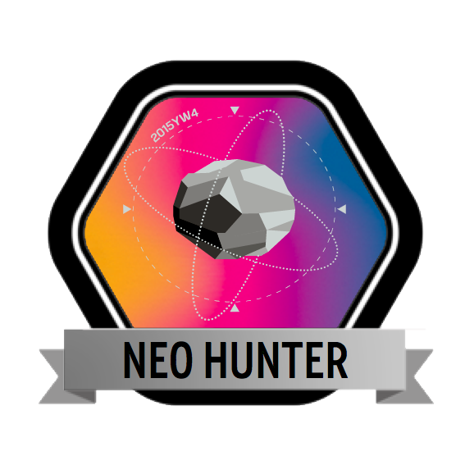  Asteroid Grand Challenge “Find Them Now Video, created through a video context to describe the work to detect, track, characterize, and mitigate potentially hazardous asteroids.  Frontier Development Lab is an applied research accelerator designed to enhance NASA’s capability by matching emerging talent from academia with peers and technology within the private sector. The Lab operated from June 27 through in August 5, 2016, and is now complete. Feel free to discover all the Lab results.  Victoria Friedensen is NASA’s point of contact for Asteroid Grand Challenge activities. | x | x

4. Conclusion

NASA will continue to lead federal agencies as we experiment with and create innovative frameworks for citizen participation in our journey to explore the universe of knowledge about our existence in the universe. We understand that not every human will touch space...yet, but in the meantime, we will endeavor to provide opportunities for citizens to engage with us in meaningful ways, and continue to provide access to our research, technology, and data to that it can be used to make their lives better. We generally err on the side of over-sharing -- with the greatest number of public websites of any federal agency. We believe in you, and expect you to surprise us as you innovate around our data and discoveries.

Cross-cutting objectives are found in 2010 Plan on page 10, and 2012 Plan on page 18.
International Space Station partnership agreements: http://www.nasa.gov/mission_pages/station/cooperation/index.html

